Forecasting Snow in the Bayou State
By: Don Wheeler, Meteorologist
Bayou State Weather, LLC

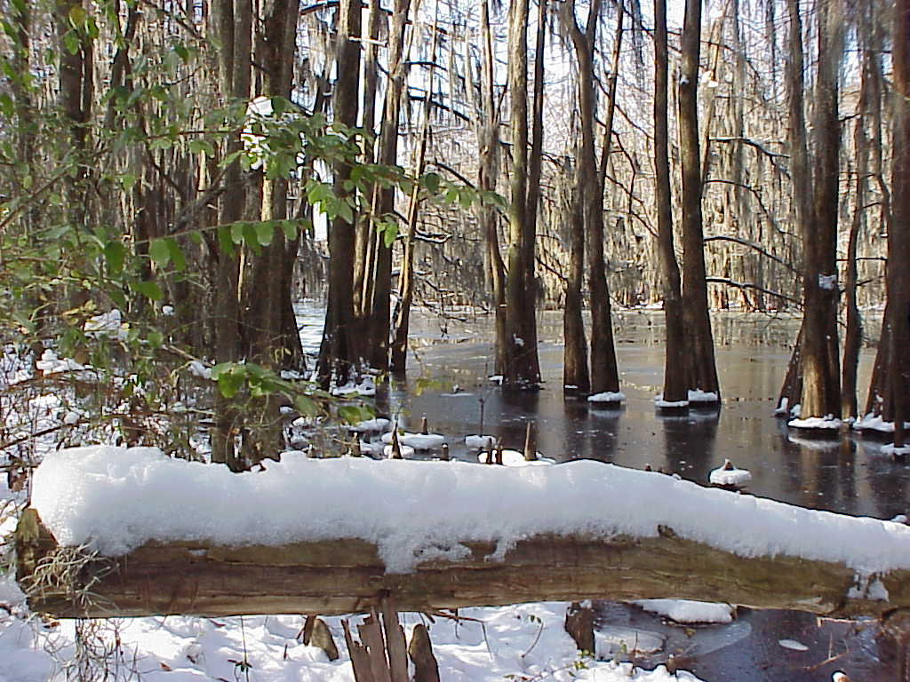

For the young and the young-at-heart, few phrases strike as much excitement into the soul of Southerners as hearing, “Snow Day!”. A break from school or work and the opportunity to build a snowman, have a snowball fight, or even eat snow ice cream. For our friends up north, the snow is usually plentiful but there an infrastructure is in place that allows for a quick clearing of the streets and thus, life goes on.

Because of the rarity of snow in the south, widespread snow removal equipment is not practical in the inventory. It may be years, perhaps decades, between snow events. Even the mention of light snow or flurries stirs the weatherwise into a state of alert. The anticipation of such a rare and beautiful event is just one of pressures put on meteorologists to “get it right” with “it” being the forecast. Even the mention of the possibility of a brief one-day light snow event often sends panicked shoppers to the grocery store for the most perishable items for a debilitating weather event: milk and bread! Life simply becomes altered, if only for a brief period of time.

So why is it so difficult to forecast snow in the Deep South, particularly in Louisiana? There are many factors that contribute to the difficulty, temperature being one. Let us use the analogy of the Goldilocks Zone. The Goldilocks Zone is a term used to describe planets in a solar system that could support life. For example, Venus, Earth, and Mars are considered to be in the Goldilocks Zone in our solar system where conditions could be conducive for life based on the distance from the sun. Venus is very hot, but if not for the runaway greenhouse effect there, the planet could sustain life, although it would likely be quite marginal. Earth is “just right” with perfect conditions to support life. Mars, being rather cold, could still support life but, like Venus, it would be marginal. So, the Goldilocks analogy can be used for snowfall in the United States. In the northern plains and Canada, it is cold like Mars so snow is easy to predict but moisture is usually limited. The middle portion of our country is also easy to predict for snow as moisture is usually plentiful with systems tapping into the Gulf of Mexico and vertical temperature profiles are conducive for snow. This zone would be considered “just right.” The South and tropics are more akin to Venus. Moisture is often plentiful but those warm temperatures just keep the snow at bay. The perfect meteorological setup must align to get that elusive snow event.

Back in Meteorology 101, the instructor commented on a question he had received. “Why does it sometime rain across the street but does not rain in my yard?” His answer was simple and applies in this discussion, “There has to be a boundary somewhere.” For us in Louisiana and most of the Deep South, we are often on that boundary between “Earth and Venus” in the Goldilocks Zone. Conditions are almost always marginal. Will we get snow, rain, or a wintery mix?

Vertical Profiles

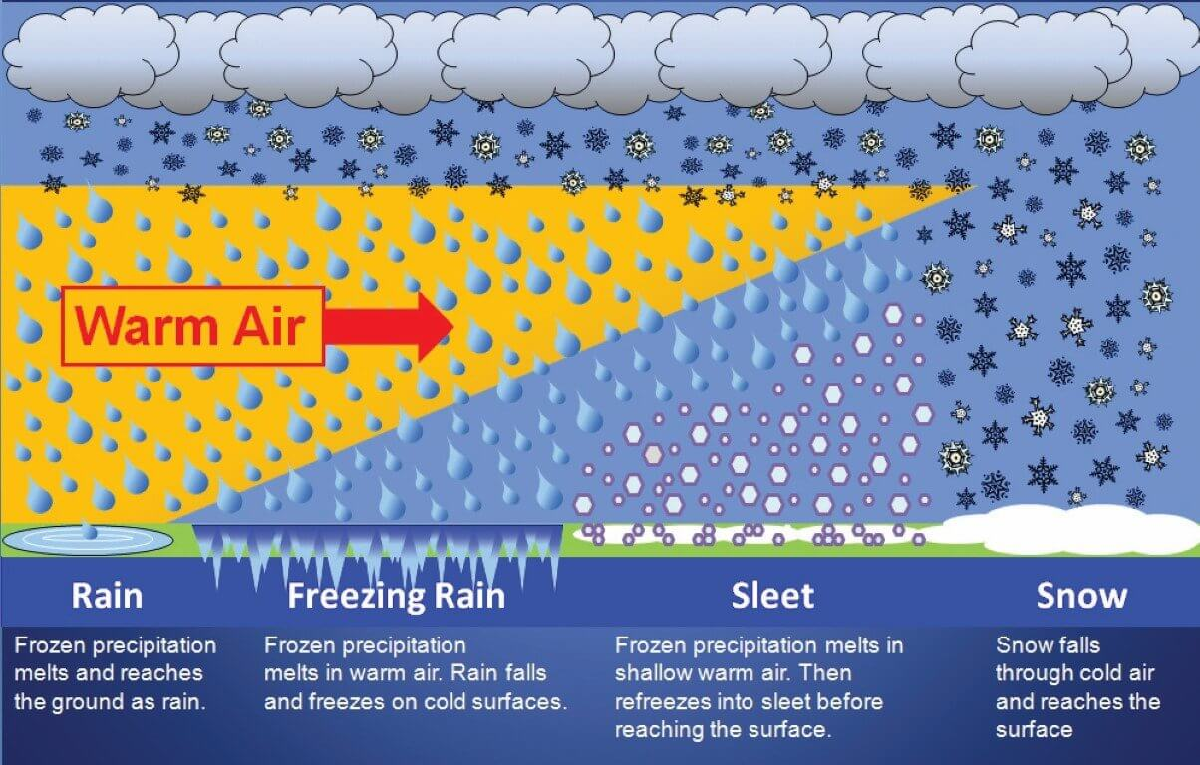
Atmospheric Setup for Winter Weather. View is Looking from East to West

The type of precipitation that falls during a winter weather event is largely dependent upon the vertical structure of the lower atmosphere with regard to temperature. Often Arctic air masses that penetrate into Louisiana are rather shallow with the denser cold air being close to the surface. In the diagram above, south is to the left of the image and north is to the right looking from east toward the west.

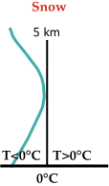
The following diagrams will illustrate the basic conditions needed for each type of precipitation that could be associated with a winter weather event: snow, sleet, freezing rain, and rain.

In the first diagram, the deepest cold air is furthest north which will allow the entire vertical column of air to be at or below freezing. Thus, snow would be the primary type of precipitation to fall in this area. The diagram to the left shows the vertical temperature (green line) in relation to the 0C/32F line. Note the entire temperature profile is at or below 0C/32F.

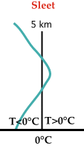
As we move further south, the cold air at the surface becomes shallower with a thin layer of warm air above it. This will allow any snow that forms in the cloud layer to melt, then refreeze into ice pellets/sleet before making it to the surface. In the accompanying diagram to the right, note the temperature (green line) briefly rises above freezing just long enough to melt the snow but enough distance is available to allow the liquid precipitation to refreeze before reaching the surface.

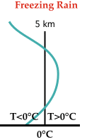
Continuing further south, the cold air becomes even more shallow which does not give any liquid precipitation time to refreeze before it reaches the ground. However, the air and objects near the surface are at or below freezing allowing the liquid precipitation to freeze on or shortly after contact with surfaces. Note on the diagram at the left the green temperature line extends further into the area above the freezing line than with the sleet diagram above.

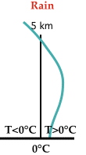

Finally, we reach a point furthest south where the entire lower column of air is above the freezing point; therefore, only liquid precipitation falls in this zone.

Winter Weather Checklist

John D. Gordon (n.d.) of the National Weather Service in Springfield, Missouri published a comprehensive checklist for forecasting a variety of winter weather. While this list is far from exhaustive as local nuances are not taken into consideration, it is quite helpful in getting a general handle on or feel for the probable or potential precipitation outcome.

Most forecasting techniques begin with determining the general rain/snow line by using thickness values, specifically the “540 line” or the 5,400-meter thickness between 1000 and 500 millibars. The map below depicts this line (thick blue line). In general, values less than 5,400 are conducive to snow and values more than 5,400 are more conducive to rain. It should be noted that this information alone should never be used to determine precipitation type. One bias, especially in the south, is that a nose of warm air is often present in the lower levels just above the surface which affects precipitation type.

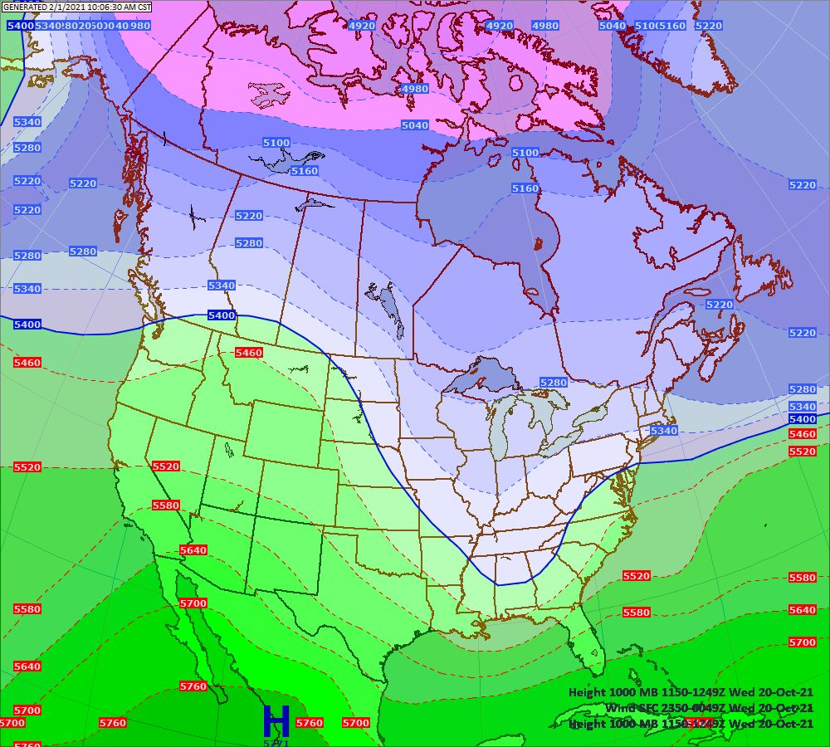

Jeff Haby (n.d.) explains the 540 line as follows:

The 540 line is in reference to a 5,400-geopotential meter thickness between 1000 and 500 millibars. Thickness is a primary function of the temperature of the air and a secondary function of the moisture content of the air. Temperature and moisture are combined together to produce the virtual temperature. The average virtual temperature from 1000 to 500 millibars determines the thickness displayed on analysis and model progs. Warming the temperature or adding moisture to the air will increase the virtual temperature and will therefore increase the 1000 to 500 mb thickness. When the thickness becomes low enough, snow can reach the surface. Through researching the correlation between thickness and precipitation type, the 540 thickness is used "generally and loosely" as the non-snow / snow line. Thicknesses of 540 or lower indicate snow is most likely (50% of time a 540 thickness will produce snow at elevations below 1000 feet) and thickness values of greater than 540 most likely indicate non-snow precipitation. There are many circumstances in which a lower than 540 thickness can produce rain and a higher than 540 thickness can produce wintry precipitation.

The table suggested by Gordon (n.d) is shown below. Several critical thickness values are given for determination along with the 5,400-thickness value. Again, this table is by no means an absolute for determining precipitation type. Remember, a value of 5,400m indicates potential snow only 50% of the time.
Table I RAIN/SNOW LINES USING THICKNESS
Critical Thickness | Rain/Snow Line
1000-500 mb | 5400 m
1000-700 mb | 2840 m
1000-850 mb | 1300 m
850-700 mb | 1540 m
850-500 mb | 4100 m
700-500 mb | 2560 m

Haby (n.d.) further refines the use of the thickness chart as below. He emphasizes that, “The temperatures between the surface and 700 millibars are much more important in determining the precipitation type than the temperatures between 700 and 500 millibars. Because of this, the 1000-700 mb thickness is superior in assessing snow threat.”

1000-500 mb Thickness  (elevations less than 1000 feet) | 1000-700 mb Thickness  (elevations less than 1000 feet)
5340 gpm – Greater than 50% | 2820 gpm – Snow very likely
5400 gpm – 50% of time snow occurs | 2840 gpm – Snow likely
5460 gpm – Less than 50% | 2860 gpm – Snow not likely

Gordon (n.d.) then includes a table targeted at forecasting snow. Note other tables are included in his paper such as forecasting freezing precipitation, heavy snow, and snow accumulations. For our purpose here, the focus will be on forecasting snow.
TABLE IV FORECASTING SNOW
SNOW | CURRENT/FCST

a. Is the surface temp <35 F (1.7 C)? | Y | N | Y | N
b. Is the freezing level <1200ft (366m)? | Y | N | Y | N
c. Is the 850 mb temp <0 C? | Y | N | Y | N
d. Is the 700 mb temp <-4C? | Y | N | Y | N
e. Is the 1000-500mb thickness <5400m? | Y | N | Y | N
f. Is the temp <0 C from 1200ft to 700 mb? | Y | N | Y | N
g. Is there a moist layer (T-Td depression 5C from surface to 700mb? | Y | N | Y | N

Situation Applications

Analysis of the snowfall event of January 10-11, 2021 (Monroe, LA)

 | Current Value  0000Z(1/10/2021)/6PM CST (1/9/2021) | NAM Forecast Value (24 hrs) at 0000Z(1/11/2021)/6PM CST (1/10/2021) | GFS Forecast Value (24 hrs) at 0000Z(1/11/2021)/6PM CST (1/10/2021) | Current “Y or N” | Forecast “Y or N”
Surface Temperature <35 F/1.7C | 40 | 37 (actual 37) | 38 (actual 37) | N | N/N
Freezing Level <1200ft/366m | 839m | 216m (actual 217m) | 220m (actual 217m) | Y | Y/Y
850mb temp <0C | 1C | -4.1C (actual -2.5C) | -1.7C (actual -2.5C) | N | Y/Y
700mb temp <-4C | 0.5C | -1.6C (actual -4C) | -2.9C (actual -4C) | N | Y/Y
Critical Thickness Value 1000-500mb <5400m | 5452m | 5408m (actual 5413m) | 5396m (actual 5413m) | N | N/Y
Temp <0C from 1200ft/366m to 700mb? | No | Yes (actual: Yes) | Yes (actual: Yes) | N | Y/Y
Is there a moist layer (T-Td depression 5C from surface to 700mb | No | Yes (actual: Yes) | Yes (actual: Yes) | N | Y/Y

The snowfall event of January 10-11, 2021 across north Louisiana produced snowfall amounts of 2 to 6 inches. The event was short lived and, as typical for the area, a marginal event. None-the-less, upper-level dynamics were conducive for a snowfall event even though temperatures at the surface were only near or a few degrees above freezing.

While “current conditions” were not indicative of a snow event 24-hours prior to the onset (see above chart), forecasted models were showing conditions conducive for snowfall. Note that other models were favoring a snow event, however, for space purposes, only the NAM and GFS models are being depicted. Note the forecast surface temperature by both models at the onset were both well above freezing with the NAM forecasting 37 degrees at 0000Z on 1/11 (6PM CST 1/10) and the GFS forecasting 38 degrees. The actual temperature proved to be 37 degrees. The forecasted freezing level was 216 meters by the NAM and 220 meters by the GFS. The actual value as of 0000Z on 1/11 was 217 meters. The critical thickness forecast by the NAM was 5,408 meters, just slightly above the 5,400 criteria while the GFS was forecasting 5,396 meters for 0000Z on 1/11. The actual value was 5,413 meters, again within the margin but on the upper end.

A cold front had pushed through the state and had stalled across the northern gulf. An approaching upper level low out of Texas induced a surface low on the front in the northwestern gulf. Both areas of low pressure marched east in tandem which produced the winter weather event on the northern edge of the precipitation shield.

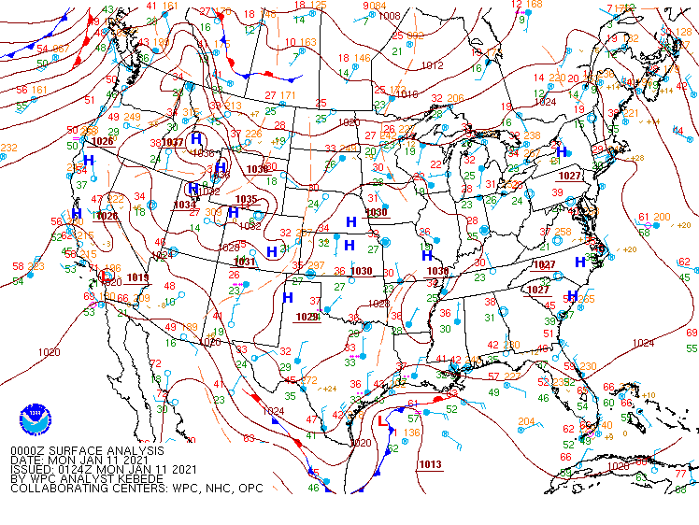
0000Z January 11 Surface Map Depicting Surface Low in the Northwest Gulf
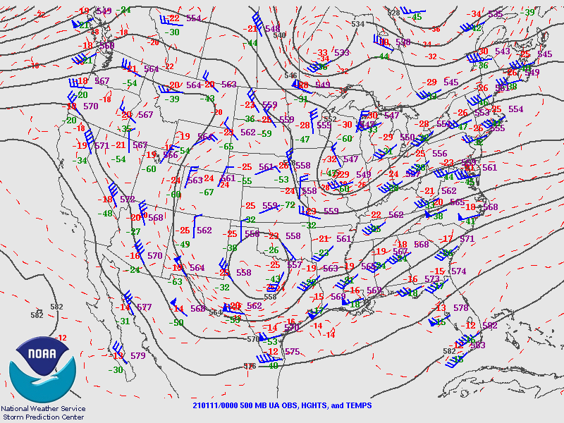
0000Z 500mb Map Depicting Upper-Level Low over Texas

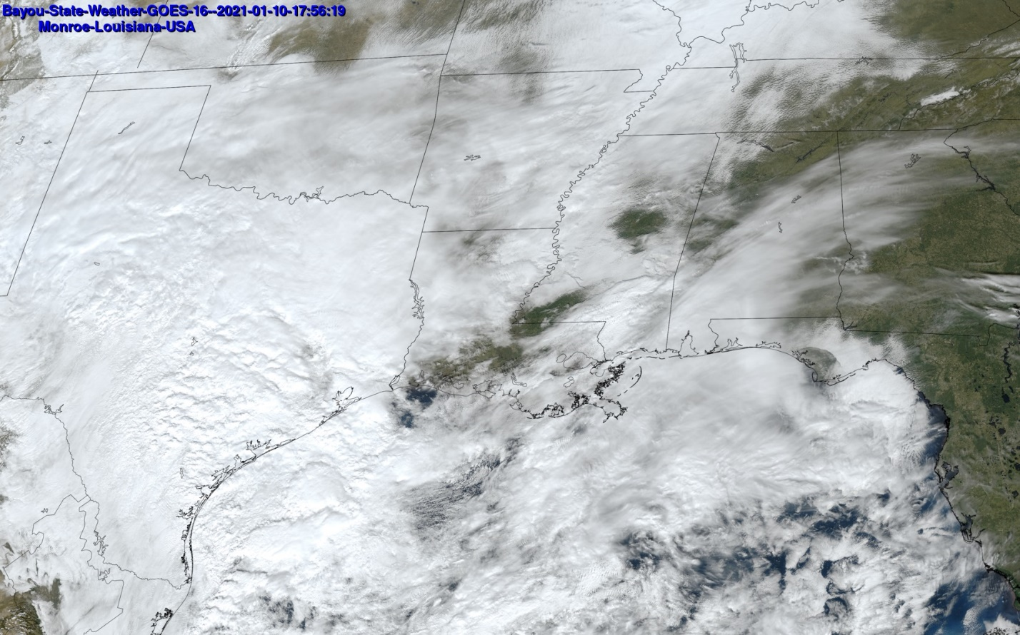
Visible Satellite Imagery from Bayou State Weather, LLC Showing Developing Winter Storm

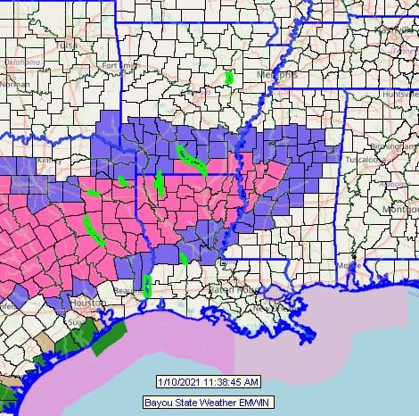
Pink areas depict a Winter Storm Warning. Blue areas depict a Winter Weather Advisory

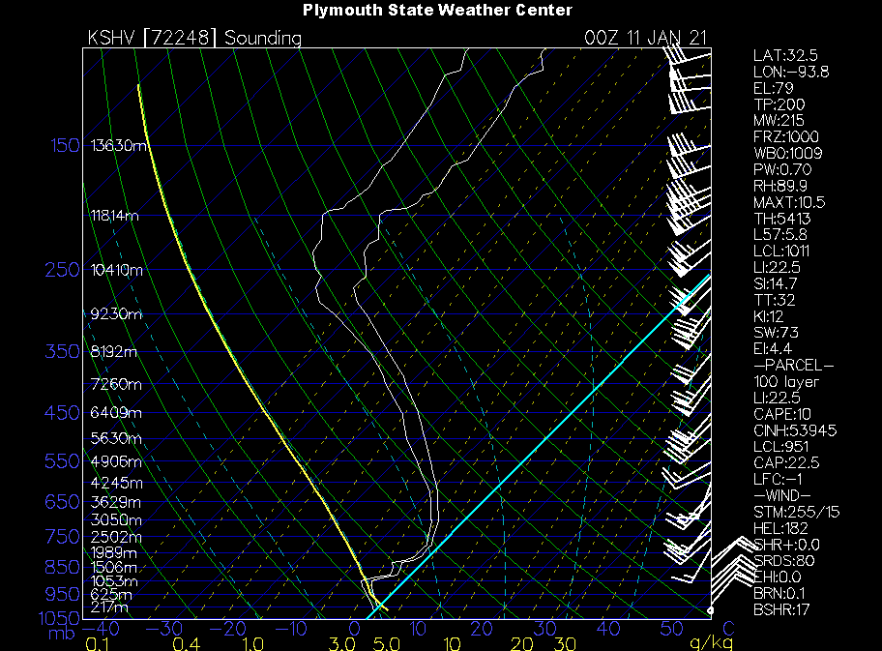
The Shreveport sounding as of 0000Z on 1/11 at the onset of the event that with the exception of surface temperatures being slightly at or above freezing, the column of air above the surface was entirely below the freezing mark (light blue line) with the temperature line being the right-most white line.

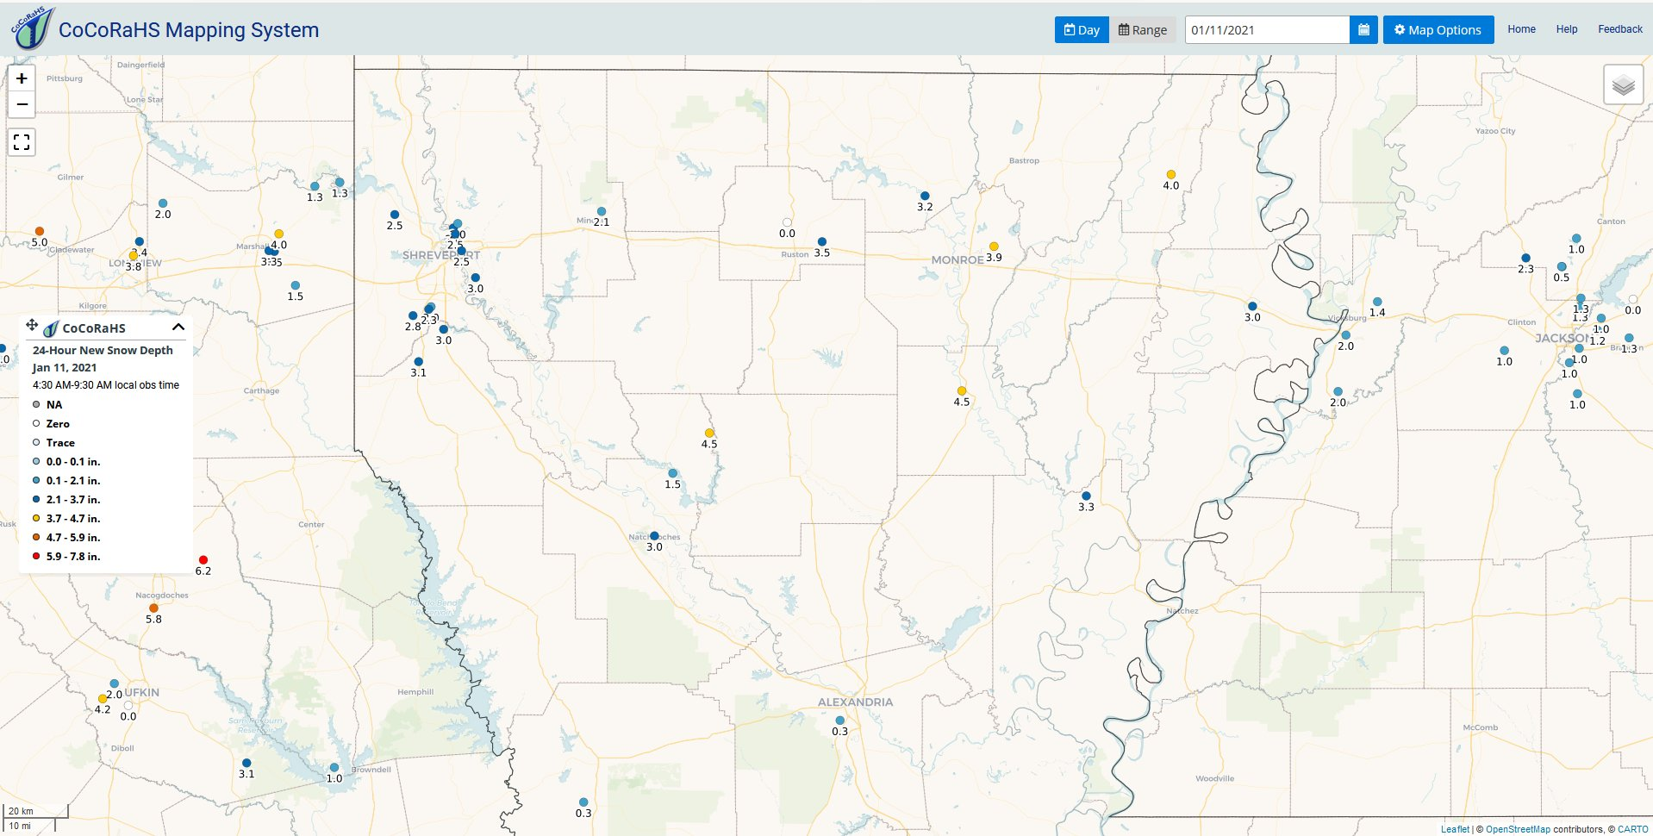
Snowfall Totals from the CoCoRaHS Network for January 11, 2021

The snowfall event of January 10-11, 2021 was one that was more conducive of snowfall. This was because cold air was in place, moisture was available, a surface low in the gulf, and a strong upper-level low moving in from the west. A more difficult snowfall forecast involves the arrival of a strong Arctic cold front.

Often Arctic fronts produce rain along and ahead of the front with some precipitation just behind the boundary. Dry air immediately begins to filter in at the surface and just above it. By nature, most Arctic fronts are accompanied by a shallow airmass so the vertical profile is usually not initially conducive for snowfall but can become cold enough with time. While the atmosphere begins to cool down in the vertical, the dry air also begins to taper off the precipitation. It is this “race” before temperatures cool down enough for frozen precipitation and the available moisture that proves to be difficult in forecasting snowfall with Arctic fronts.

This was the case with the forecasted event of January 28, 2019. Models were split as to whether the temperature profile would cool down quick enough before the end of the precipitation to produce snow.

Analysis of the “busted” snowfall event of January 28, 2019 (Monroe, LA)

 | Current Value  0000Z(1/29/2019)/6PM CST (1/28/2019) | NAM Forecast Value (6 hrs) at 0600Z(1/29/2019)/12AM CST (1/29/2019) | GFS Forecast Value (24 hrs) at 0000Z(1/29/2019)/12AM CST (1/29/2019) | Current “Y or N” | Forecast “Y or N”
Surface Temperature <35 F/1.7C | 60F | 42F (Actual 44F) | 39F (Actual 44F) | N | N/N
Freezing Level <1200ft/366m | 6680ft/2036m | 760m | 700m | N | N/N
850mb temp <0C | 5.3C | 1C | -2C | N | N/Y
700mb temp <-4C | -7.5C | -5C | -8C | Y | Y/Y
Critical Thickness Value 1000-500mb <5400m | 5463m | n/a (Actual 5463m)  Forecast thickness was not available | n/a (Actual 5463m)  Forecast thickness was not available | N | n/a
Temp <0C from 1200ft/366m to 700mb? | No | Not entire column | Yes | N | N/Y
Is there a moist layer (T-Td depression 5C from surface to 700mb | Yes | Yes | Yes | Y | Y/Y

Utilizing the checklist above, we can observe that conditions only a few hours prior to the event were anything but conducive for winter precipitation. At 6PM CST on 1/28 the temperature at the Monroe Airport was 60F with little in the way of vertical profile support. None-the-less, key models were indicating a changeover from rain to snow would occur before the precipitation came to an end behind the strong Arctic front. The GFS and the RAP were showing the changeover to take place while the NAM, not-so-much. The above graph depicts conditions and/or forecast conditions for a specific point in time and does not easily take into consideration rapidly changing conditions associated with a strong frontal passage.

The meteogram below indicates forecasted accumulated snow amounts from the various model outputs. Note that models that did not indicate accumulating snow were grouped together on the graph across the zero-axis running from left to right and are not discernable on the graph.

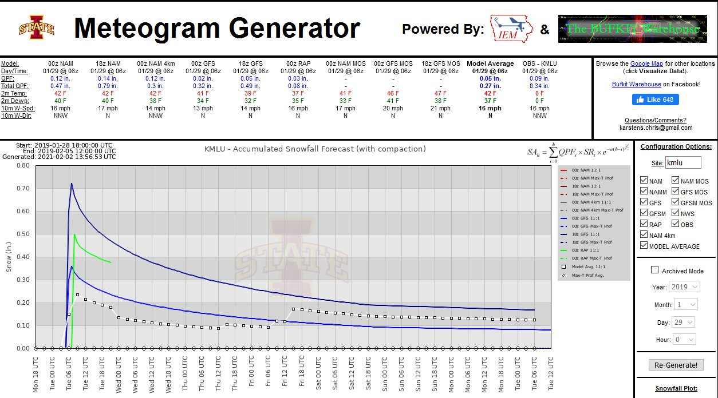
Meteogram of Forecast Snowfall Accumulation for January 28, 2019

As so often with these types of events when conflicting models are present, the forecaster is faced with the dilemma of making the difficult forecast. In this case, many local meteorologists including forecasts from two National Weather Service offices, opted to forecast accumulating snow. Official snowfall forecast totals were in near one-inch across northeast Louisiana with even higher amounts into Mississippi.

The 0600Z (12AM CST) surface map depicts the Arctic front passing through central Louisiana. Even at this time, the air temperature at Monroe, Louisiana had only fallen to 44 degrees and temperatures were still above freezing across south Arkansas. Also note that El Dorado in south Arkansas was already showing clear skies!

By the end of the event, only one station near Natchitoches reported a “Trace” of frozen precipitation. Further east, however, stations around Jackson, Mississippi did report amounts upwards to 0.3”. For Louisiana, the atmosphere did not cool down enough prior to the abrupt end of the precipitation. The forecast was a bust.
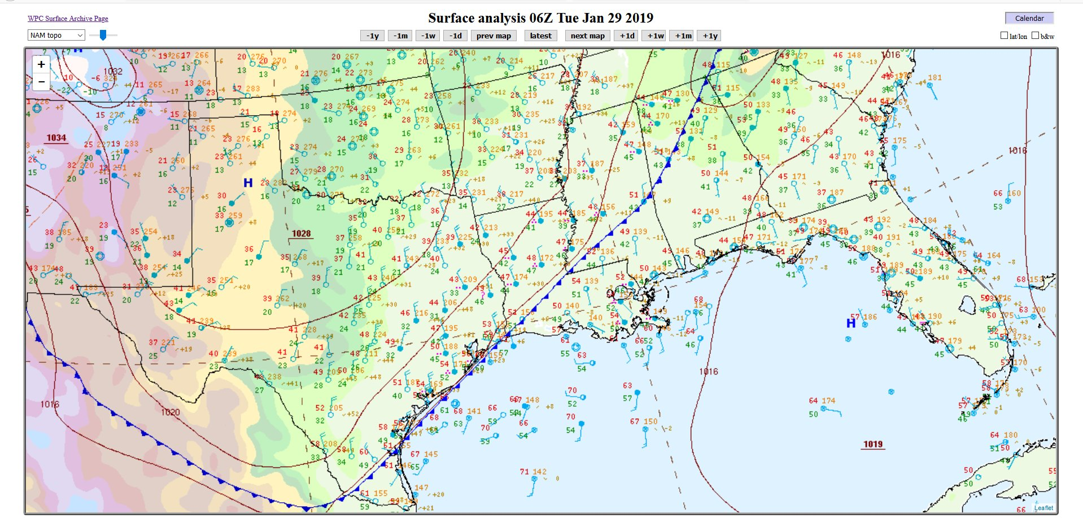
Surface Map at 0600Z January 29, 2019

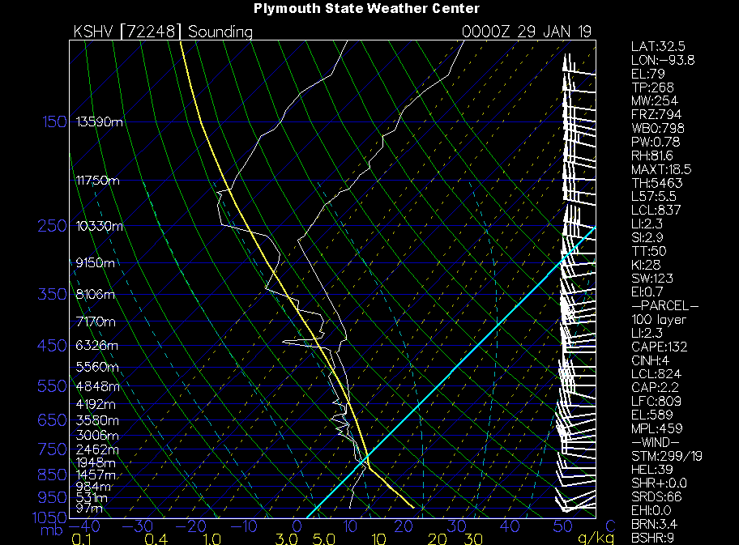
0000Z January 29 Sounding from Shreveport, Louisiana. Light Blue Line is Freezing.

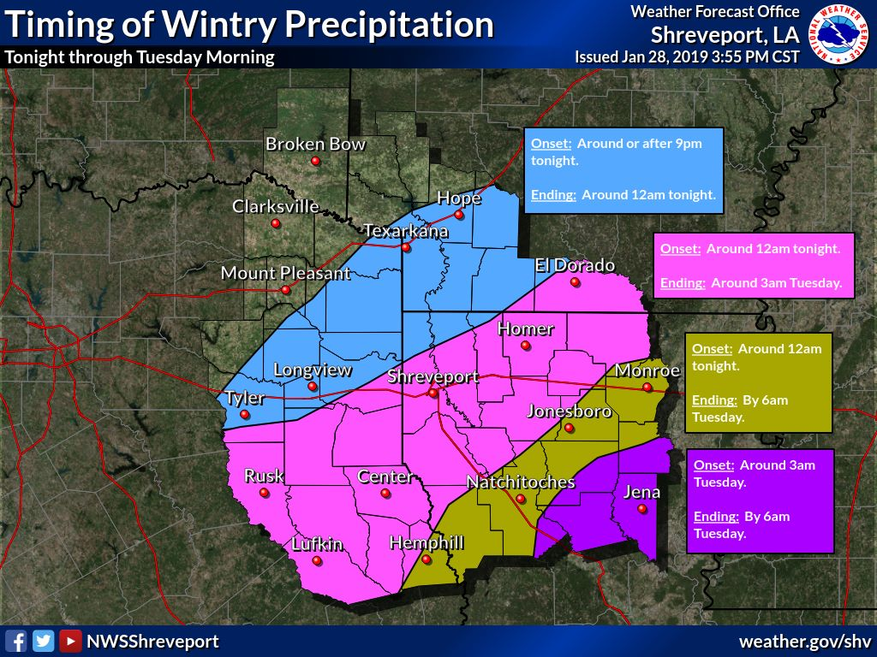
Estimated Time of Arrival/Onset of Winter Precipitation. A look at the “Time of Arrival” map does indicate that the forecast event would be a quick one with the window of opportunity of only about three-hours.

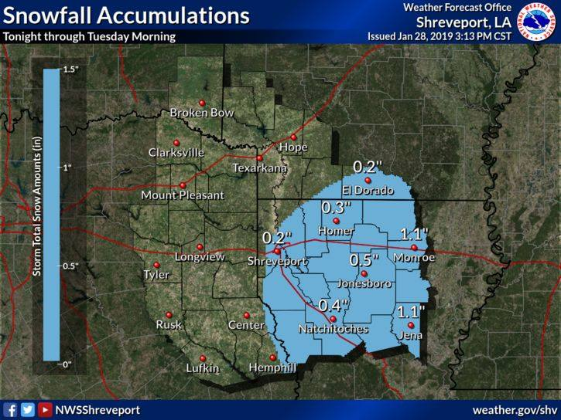
Forecasted Snowfall Amounts from NWS-Shreveport for the January 28, 2019 Event

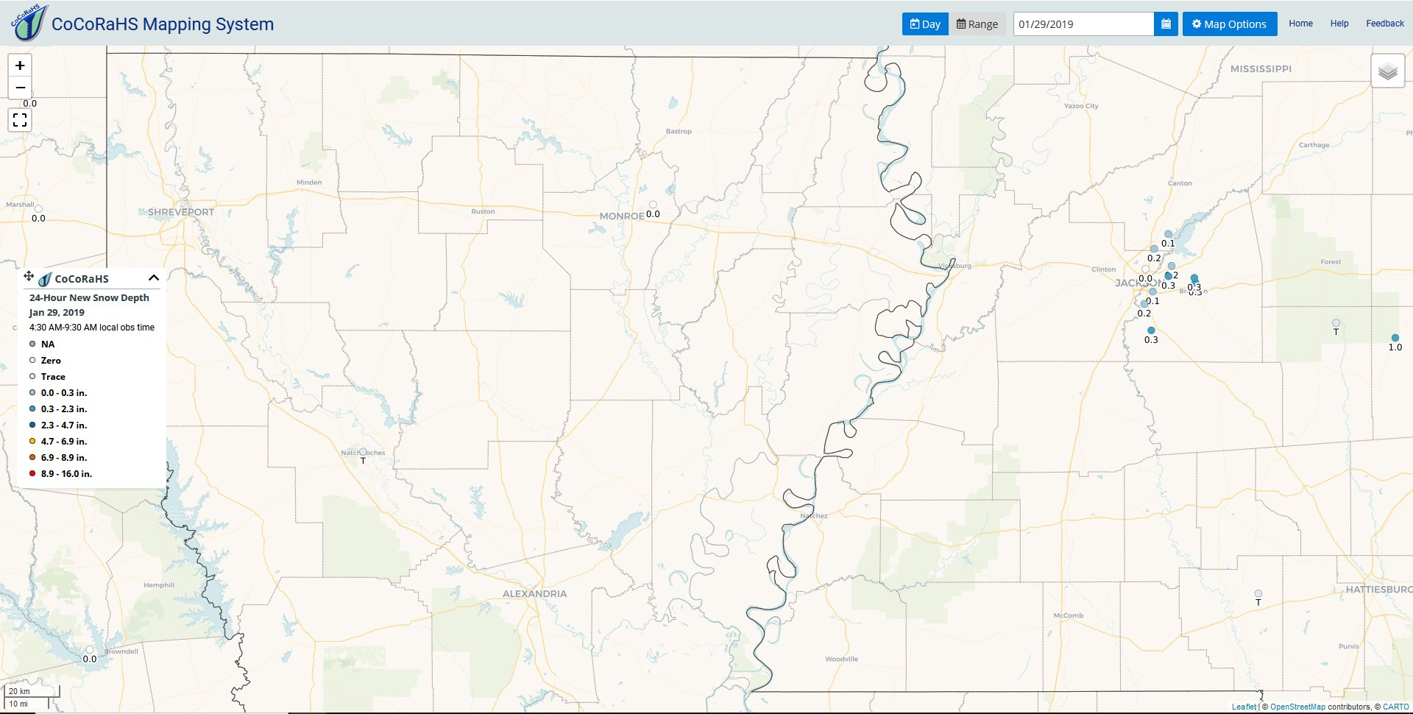
Actual Snowfall Accumulations Reported via the CoCoRaHS Network.

Model Discrepancies

As mentioned in the January 28, 2019 busted snowfall forecast, discrepancies in models often add to the dilemma in forecasting winter weather events, especially in the long-range time frame. One such example was predicting the arrival of a major Arctic cold outbreak during the second week of February, 2021. Initially, models were in somewhat of an agreement in that cold air would be penetrating the deep south during the latter half of the week of February 8-13, 2021. The GFS was the colder model, the ECMWF was the warmer of the two and the Canadian was in the middle.

During the latter part of the week prior to the event, the ECMWF began to trend very warm while the GFS became colder with temperature differences of over 20 degrees! The GFS was showing several periods of potential winter precipitation while at the same time the warmer ECMWF was showing liquid precipitation.

An example of the 00Z runs on February 7 of both the GFS and ECMWF shows a 26-degree difference in 2-meter air temperature forecast for 12Z on February 15, 2021 for Monroe, Louisiana (GFS: 21F/ECMWF: 47F) and the same for Alexandria, Louisiana (GFS: 26F/ECMWF: 52F).

These two models at the same initiation period also indicated differing types of precipitation for 06Z for February 16. The GFS showed an area of winter precipitation across northwest Louisiana and south Arkansas with a southwest to northeast band of liquid precipitation from southwest Louisiana to western Mississippi. The ECMWF only depicted the southwest to northeast oriented band of liquid precipitation.

These model differences over an extended period of time as well as excessive inconsistencies between model runs became the focus of much discussion and uncertainty among the meteorological community leaving many forecasters to make a “best guess” as to what may be happening 7-10 days out.

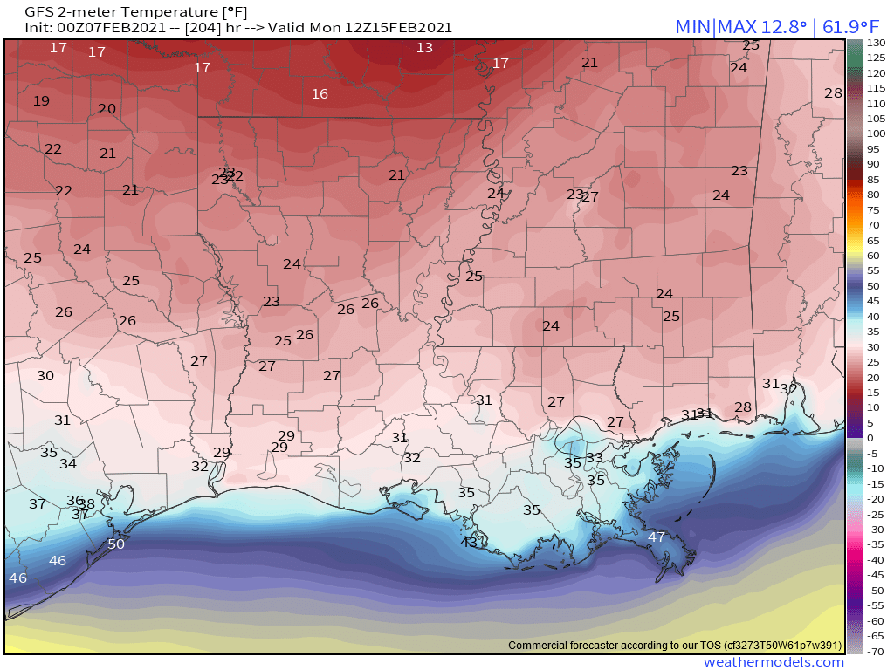  GFS 2-Meter Temperature Forecast 12Z 2/15/2021 | 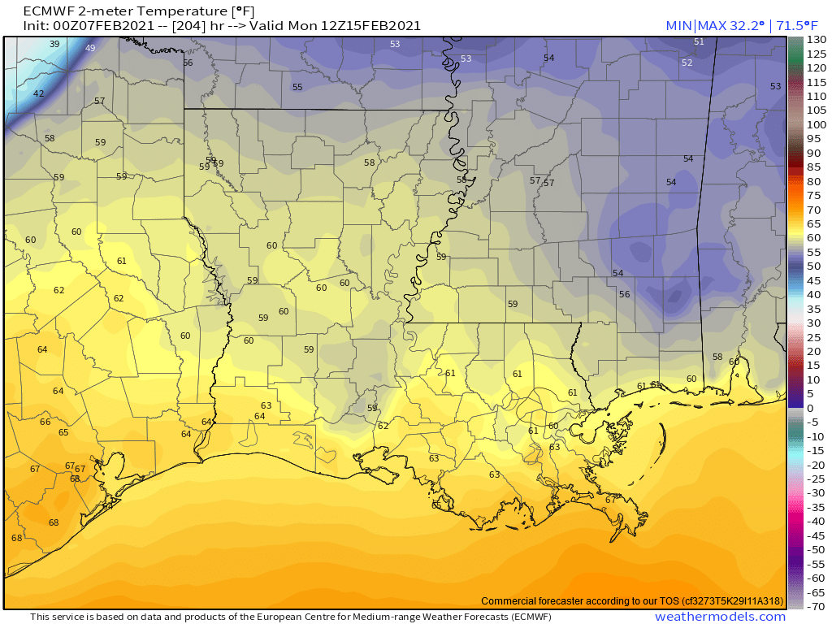  ECMWF 2-Meter Temperature Forecast 12Z 2/15/2021

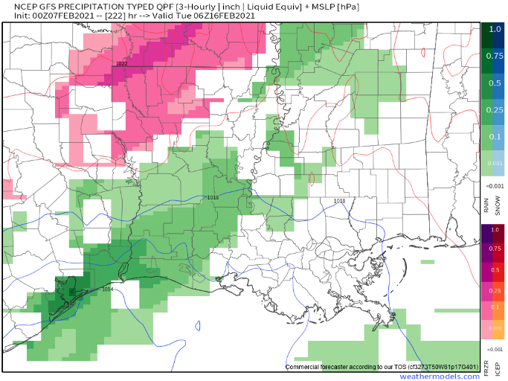  GFS Precipitation Forecast 06Z 2/16/2021 | 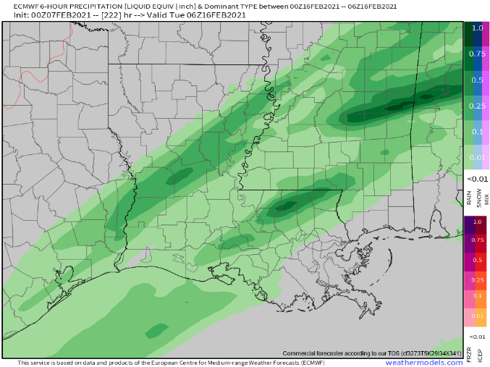  ECMWF Precipitation Forecast 06Z 2/16/2021
Conclusion

Forecasting winter weather, particularly snow, in the deep south is often difficult and frustrating. On rare occasion parameters do come together for a relatively easy forecast for snow; however, more often than not, those perfect parameters are a rare occurrence. The location of Louisiana on the warm end of the Goldilocks Zone is the primary culprit. The close proximity to the Gulf of Mexico and the southern latitude simply inhibit the right ingredients from coming together for snow to be common and let us not even begin to discuss the elusive white Christmas!

An exhaustive list of case studies could be presented as to why one event produced snowfall and a nearly identical event produced no snowfall or a winter mix or rain or nothing at all. For now, we are at the mercy of forecasting winter weather in a marginal zone for it and relying on numerical computer models that can be just as affected by those same southern latitude parameters. Meteorologists must rely on skills of recognizing which model has the best grasp on a given weather scenario as well as past experience and a familiarity with the local climate.

While great strides in forecasting are constantly made, forecasters constantly struggle to accurately forecast snow. Even in snow-prone areas, forecasters sometime face difficulty in making a crucial “snow or no snow” forecast. But because of the rarity of snow in the Deep South coupled with the anticipation of seeing those elusive white flakes, those forecasts will never be as challenging as those for us down south.

References
Bayou State Weather, LLC: http://www.bayoustateweather.com
Community Collaborative Rainfall, Hail, and Snow Network (CoCoRaHS): https://www.cocorahs.org/
Gordon, J. D. (n.d.). A COMPREHENSIVE WINTER WEATHER FORECAST CHECKLIST. Retrieved January 30, 2021, from https://www.weather.gov/source/zhu/ZHU_Training_Page/Miscellaneous/Heights_Thicknesses/thickness_temperature.htm
Haby, J. (n.d.). THE 540 LINE AND PRECIPITATION TYPE. Theweatherprediction.Com. Retrieved January 30, 2021, from http://www.theweatherprediction.com/habyhints/97/
Iowa State University: https://meteor.geol.iastate.edu
NOAA/National Weather Service/Weather Prediction Center: https://www.wpc.ncep.noaa.gov
NOAA/National Weather Service – Shreveport, Louisiana: https://www.weather.gov/shv/
Plymouth State University: https://vortex.plymouth.edu
WeatherModels.com: https://weathermodels.com

